# Whiley Valid Test Results

Total number of tests: 593 tests.

|  |  |  |  |  |  |
| --- | --- | --- | --- | --- | --- |
| Date | Failed | Passed | Skipped | Executed | Execution Time (5 runs) |
| 25/05/18  No optimisation | 76 errors, 25 failures | 422 | 70 | 523 | None |
| 26/06/18  No optimisation | 75 errors, 88 failures (only 16 failures, others due to precondition) | 360 (432) | 70 | 523 | 43.404s  44.723s  43.662s  44.068s  43.709s  = 43.913s |
| 26/06/18  Optimisation | 97 errors, 78 failures (only 17 failures, others due to precondition) | 348 (409) | 70 | 523 | 42.457s  42.6s  43.003s  43.092s  42.911s  = 42.813s |

## Needs tweaking of limits but passed

72 tests, due to precondition failing on some or all inputs

|  |  |  |
| --- | --- | --- |
| Access_Valid_1 | Ensures_Valid_1 | While_Valid_12 |
| Access_Valid_2 | Ensures_Valid_4 | While_Valid_22 |
| Array_Valid_1 | Function_Valid_16 | While_Valid_23 |
| Array_Valid_3 | FunctionRef_Valid_4 | While_Valid_28 |
| Array_Valid_4 | Import_Valid_2 | While_Valid_30 |
| Array_Valid_5 | IntDiv_Valid_1 | While_Valid_33 |
| Array_Valid_6 | IntDiv_Valid_5 | While_Valid_38 |
| Array_Valid_7 | ListAccess_Valid_1 | While_Valid_43 |
| Array_Valid_8 | ListAccess_Valid_3 | While_Valid_45 |
| Array_Valid_9 | ListAssign_Valid_3 | While_Valid_47 |
| BoolAssign_Valid_3 | ListAssign_Valid_5 | While_Valid_49 |
| BoolAssign_Valid_5 | ListAssign_Valid_11 | While_Valid_50 |
| BoolRequires_Valid_1 | ListAssign_Valid_12 | While_Valid_52 |
| ConstrainedInt_Valid_21 | ListGenerator_Valid_1 | While_Valid_55 |
| ConstrainedList_Valid_1 | ListGenerator_Valid_3 | While_Valid_56 |
| ConstrainedList_Valid_2 | Property_Valid_7 | While_Valid_59 |
| ConstrainedList_Valid_7 | Quantifiers_Valid_1 | While_Valid_60 |
| ConstrainedList_Valid_9 | RecordAssign_Valid_9 | While_Valid_61 |
| ConstrainedList_Valid_16 | RecordAssign_Valid_14 | While_Valid_62 |
| ConstrainedList_Valid_23 | Remainder_Valid_1 | While_Valid_63 |
| ConstrainedList_Valid_25 | Requires_Valid_1 | While_Valid_64 |
| ConstrainedList_Valid_28 | Switch_Valid_3 | While_Valid_65 |
| DoWhile_Valid_5 | Switch_Valid_7 | While_Valid_66 |
| DoWhile_Valid_6 | Update_Valid_2 | While_Valid_67 |
|  | VarDecl_Valid_2 | While_Valid_68 |

## Failed postcondition

* Assume_Valid_1
  + Failing on negative values, due to assumption on value on line 8 causes output type invariant to fail so not quickcheck’s fault!
* While_Valid_58_result
  + Failing on negative values, due to assumption on value on line 2 which causes assertion failure on line 8 so not quickcheck’s fault!

## Assertion Failure

|  |  |
| --- | --- |
| Reason | Test |
| No function (9 tests) | * Lambda_Valid_9 * OpenRecord_Valid_3 * FunctionRef_Valid_1, 2, 5, 6, 8, 12, 13 * Function_Valid_13 (optimisation only) |
| Fail to compile (4 tests)  Due to intersection type | * ConstrainedIntersection_Valid_1 (for the *is* clause, expected type byte found bool) * Intersection_Valid_1, 2 (intersections don’t work) * NegationType_Valid_3 (intersections don’t work) |
| Assertion error (1 tests) | * ConstrainedList_Valid_9 |
| Precondition failure (72 tests) | * See Table above |

## Error

|  |  |
| --- | --- |
| Reason | Test |
| StackOverflow (12 tests)    Due to recursive types? | * Coercion_Valid_8 (recursive) * ConstrainedInt_Valid_20 (function is recursive, never ends if input < 0) * Contractive_Valid_1, 3 (recursive) * FunctionRef_Valid_10, 11 (recursive + function) * RecursiveType_Valid_20, 23, 24, 26 (recursive) * TypeEquals_Valid_16, 2 (recursive) |
| Upper limit <= lower limit  (58 tests)  Just need to tweak limits | * Complex_Valid_1, 11, 5 * ConstrainedInt_Valid_10, 13, 16, 17, 19, 23, 24, 6, 8 * ConstrainedList_Valid_17, 19, 2, 20, 21, 22, 3, 6, 8 * ConstrainedRecord_Valid_1, 2 * Define_Valid_4 * Fail_Valid_3 * Function_Valid_18, 20, 4, 6, 8 * Lambda_Valid_7 * ListAssign_Valid_4 * Method_Valid_1 * RecordAssign_Valid_7 * RecordDefine_Valid_1, 3 * Record_Valid_5 * String_Valid_1 * Switch_Valid_4 * TypeEquals_Valid_1, 3, 31, 33, 39, 45 * UnionType_Valid_11, 14, 18, 2, 20, 22, 5, 7, 9 * While_Valid_16, 18, 21, 3 |
| RuntimeException (5 tests, 3 optimisation only) | * ConstrainedList_Valid_11 - Null operand * ConstrainedRecord_Valid_6 – null operand * RecordAssign_Valid_13, 4 – null operand * RecursiveType_Valid_17 – null operand * While_Valid 55, 56, 57 – null operand (optimisation only) |
| Class Cast exception – trying to cast Decl.Property to Decl.FunctionOrMethod  (Optimisation only, 18 tests) | * DoWhile_Valid_9 * Property_Valid_1, 2, 3, 5, 6, 8, 9, 13 * While_Valid_59, 60, 62, 63, 64, 65, 66, 67 |
| ArrayIndexOutOfBounds  (Optimisation only, 1 test) | * RecursiveType_Valid_16 |

May be of interest (currently disabled)

|  |  |
| --- | --- |
| NegativeArraySizeException | * While_Valid_2, 26   Due to executeArrayRange not checking end – start > 0 |

# Whiley Invalid Test Results

Total number of tests: 355 tests

|  |  |  |  |  |  |
| --- | --- | --- | --- | --- | --- |
| Date | Failed | Passed | Skipped | Total Executed | Execution Time (5 runs) |
| 25/05/18 | 4 errors, 18 failures | 316 | 17 | 338 | None |
| 27/06/18 (optimisation) | 4 errors | 331 | 17 | 338 | 9.459s  9.06s  9.354s  9.497s  9.045s  = 9.283 s |
| 27/06/18 (no optimisation) | 18 errors | 320 | 17 | 338 | 8.764s  8.671s  8.607s  8.779s  8.623s  = 8.689s |

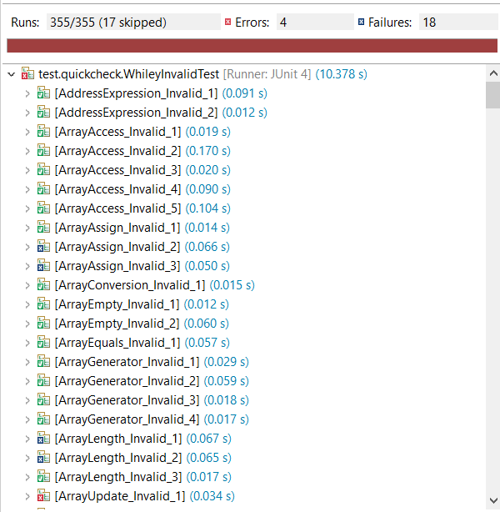

Some tests could be passing due to the loop limits used.

|  |  |
| --- | --- |
| Reason | Test |
| ArrayIndexOutOfBounds is good? (2 tests, 2 optimisation,) | * ArrayUpdate_Invalid_1 * ConstrainedInt_Invalid_7,8 (optimisation) * While_Invalid_10 |
| Class Cast exception – trying to cast Decl.Property to Decl.FunctionOrMethod  (Optimisation only, 13 tests) | * Do_While_Invalid_6, 7, 8 * Property_Invalid_2, 3, 4, 8 * While_Invalid_19, 20, 21, 22, 23 |
| DivisionByZero is good? (1 test) | * Remainder_Invalid_1 |
| RuntimeException (1 test) | * TupleAssign_Invalid_2 – null operand (technically ok as it removes invalid inputs during test gen) |

# Whiley Benchmark Tests

Total number of tests: 36 tests

|  |  |  |  |  |  |
| --- | --- | --- | --- | --- | --- |
| Date | Failed | Passed | Skipped | Executed | Execution Time (5 runs) |
| 2/07/18 | 5 errors 31 failures | 0 | 0 | 36 | None |

## Assertion Failure

|  |  |
| --- | --- |
| Reason | Test |
| Fail to compile (28 tests)  Due to external libraries required | * 001_average\main * 002_fib\main * 003_gcd\main * 004_matrix\main * 006_queens\main * 007_regex\main * 008_scc\main * 009_lz77\main * 010_sort\main * 011_codejam\main * 012_cyclic\main * 013_btree\main * 014_lights\main * 015_cashtill\main * 016_date\main * 017_math\main * 024_bits\main * 025_tries\main * 026_reverse\main * 027_c_string\main * 028_flag\main * 030_fractions\main * 102_conway\main * 104_tictactoe\main * 106_lander\whiley\src\lander\ui\LanderCanvas * 107_minesweeper\main * 108_scrabble\Board * todo\codejam_0511B\Main |
| Due to precondition (actually alright) | * 022_cars\main * 023_microwave\main |
| Due to upper > lower | * 104_tictactoe\board * 104_tictactoe\game |

## Error

|  |  |
| --- | --- |
| Reason | Test |
| NegativeArrayException | * 018_heap\main |
| ArrayIndexOutOfBounds | * 029_bipmatch\main |
| Runtime: Null operand | * 032_arrlist\main |
|  |  |